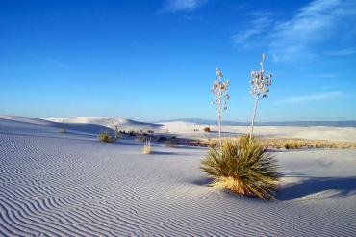
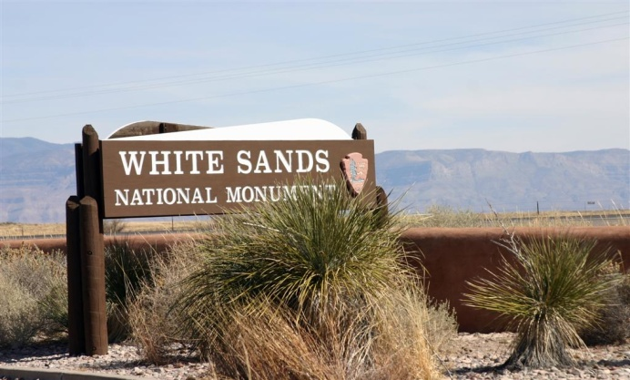
TROOP 1
White Sand
FRIDAY APRIL 8-Sunday April 10, 2016

WHO: Scouts, Parents and Old Goats of Troop One!! (This is open to families however families are expected to abide by the rules)
WHAT: White Sand Missile Range Campout.
MEET: Thursday 7:00 load trailer, Friday 5:00pm at church to depart.
DEPART: Friday 5:15pm from church
RETURN: Sunday 3:00pm at church
We will be staying on base, eating at the mess hall, visiting the dunes, swimming and probably the space museum. You won’t want to miss this one, guys!
BRING: Camping Gear, as well as an optional sled!!!! Also please bring a sack dinner for the way up on Friday.
GROUP FEE: $35 per person will cover meals and gas.
Individual costs: You may want to bring $10 in case there is a gift shop.
If you have any questions please call Scoutmaster Meyer at 730-3671
------------------------ CUT HERE ----------- CUT HERE ---------- CUT HERE ---------- CUT HERE ---------------------- CUT HERE -------------------

Scout’s Name_________________________________ Patrol _________________

Names of Adult(s) Going: ______________________________________________

What vehicle will you be driving? _________________________________________________
Year ________ Make ___________ Model _______ #Seatbelts________

